Project Development Phase Sprint - 3

|  |  |
| --- | --- |
| Date | 21 October 2022 |
| Team ID | PNT2022TMID24237 |
| Project Name | Classification of Arrhythmia by Using Deep Learning  with 2-D ECG Spectral Image Representation |

Local Deployment:

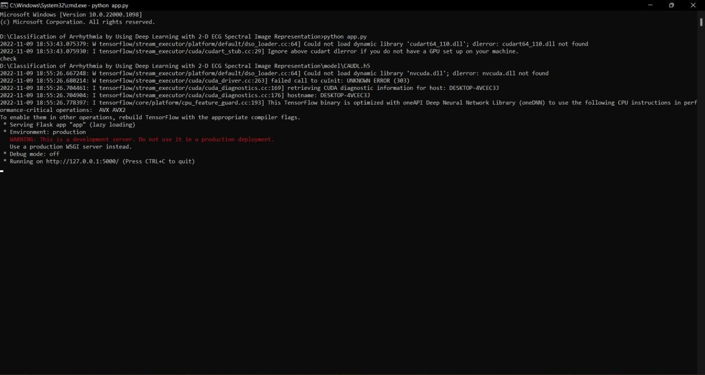

( Running App ! – Flask )

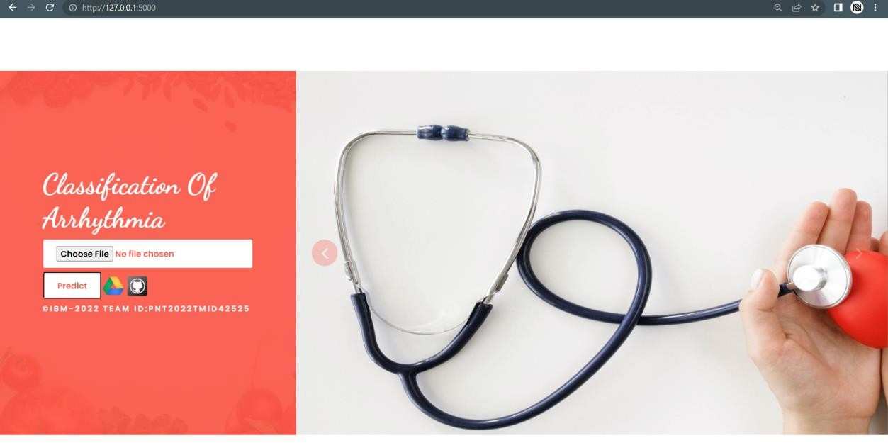

( UI Application Opens Successfully.. )

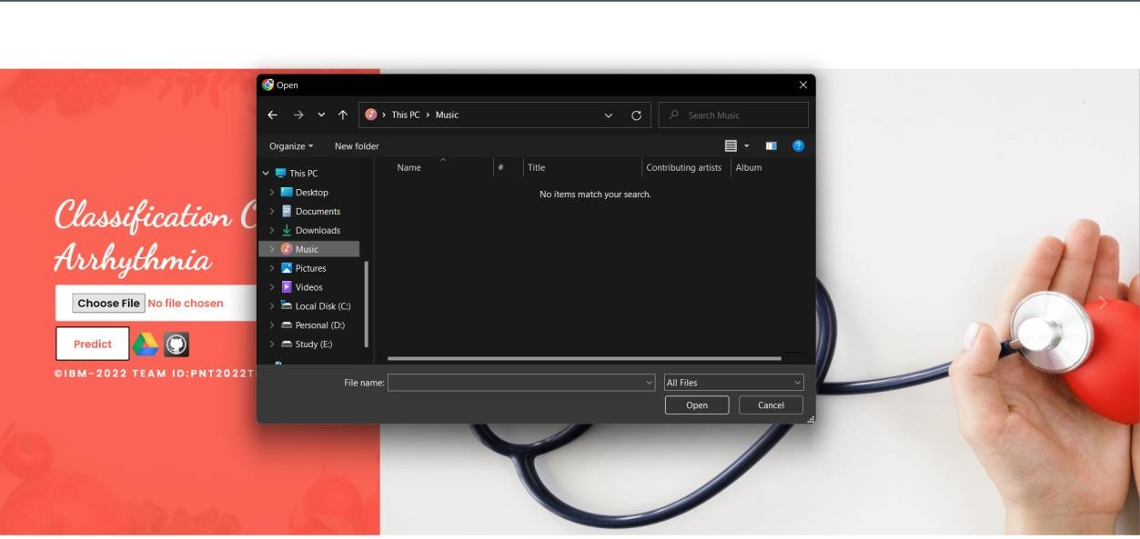

( Click Choose File To Upload Images )



( The Image Is Uploaded – Click Predict Button To Predict )

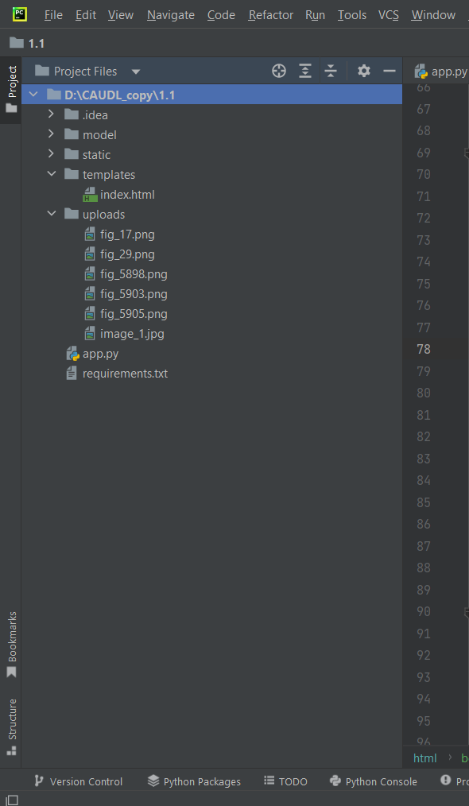

( The Uploaded Image Is Stored In The Uploads Folder !! )

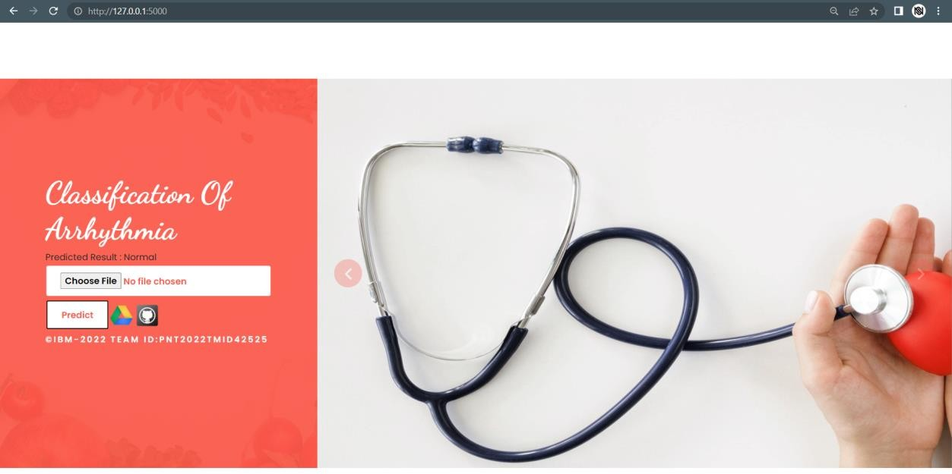

( Through “Predicted Result” The Image Classification Is Visible.. )



( Click Google Drive Button For Sharing Purposes )